C-CARD DISTRIBUTION FORM

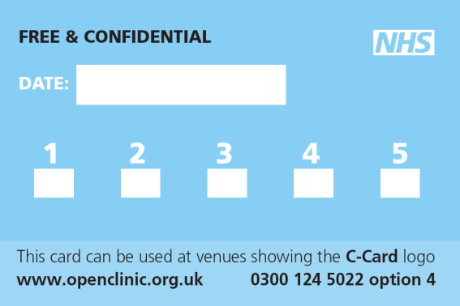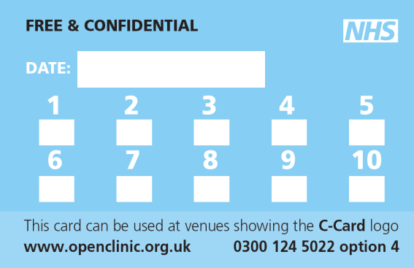
2 packs can be given per visit for over 16’s
Only 1 pack per visit for under 16’s
Visit Number
Date of Registration
C-Card Number
U – Under 16’s and Vulnerable
O – Over 16’s
14/09/19
01332
U1332
14/09/19

VENUE: MONTH:
DATE | C-CARD NUMBER | VISIT NUMBER | DISTRIBUTED BY  ( Initials) | GDPR  APPROVAL
14/01/20 | O1332 | 2 & 3  EXAMPLE | EM | √
PLEASE RETURN THIS FORM BY THE 5TH OF EACH MONTH TO:
Prevention Team, Sexual Health Service, Park House, Park Road, Cannock, WS11 1JN
Email:- mpftprevention@nhs.net or telephone 0300 124 5022 option 4

