.
Sexual Health Service Update
Stoke-on-Trent, Staffordshire and Telford & Wrekin
Spring 2024
Welcome to the Spring Newsletter for Stoke-on-Trent, Staffordshire and Telford

In this issue:
- Online Booking Now Available  - New Clinic Information  - Mirena IUS Now Licenced for 8 Years  - We Want Your Feedback! | - Easter Clinic Closures  - C-Card Reminder – No Upper Age Limit  - New QR Code Poster Available
Online Booking Now Available  People can now book an appointment online, with our new Personal Health Record system.  Setting up a Personal Health Record with our services also allows people to manage their own details, as well as booking, cancelling or rearranging their appointments.  Service users can set up a Personal Health Record, and book an appointment, on our website, www.openclinic.org.uk, by selecting the “Book Now” option. |  | 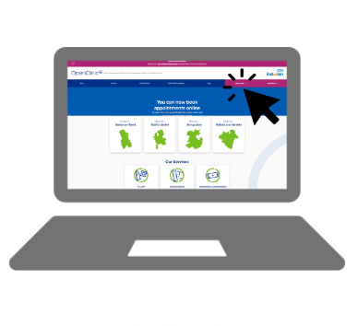
New Clinic Information

We have a number of new walk-in clinics available in Staffordshire and Telford & Wrekin:
- Bishton Court, Telford
Mondays, Wednesdays and Fridays, 8:30-11:30am
- Branston Clinic, Burton
Tuesdays, 8:45am – 11:30am
Wednesdays, 8:30am -11:30am
- Stafford Clinic
Tuesdays, 12:30pm – 2:30pm
Our sexual health clinic at Bishton Court will be opening on Wednesdays from April. There will be a walk-in clinic in the morning 8.30am-11.30am, and appointments from 1pm-3pm.

Find the latest clinic opening times on our website at www.openclinic.org.uk/clinics

Mirena IUS Now Licenced for 8 Years

The Mirena IUS (a type of hormonal coil) is now licensed for 8 years for contraception purposes.
For patients who have a Mirena already, this means that it can remain in place, and be effective, for 8 years from the fitting date. We will from now be refitting Mirenas around the 8 year date.
If a Mirena has been fitted for control of bleeding, part of HRT, or treatment for any other gynaecological problem, this does NOT apply.
The new advice does NOT apply to other IUS brands or types.
Please note that we only fit/remove coils for contraceptive purposes.

We Want Your Feedback!

We want to hear from professionals who signpost or refer people into our services. We are seeking feedback on a number of topics, such as:
- Any issues signposting to our service
- Negative feedback you hear from service users about sexual health services
- How we can improve inclusivity

Please take our quick survey here.

Easter Clinic Closures

Our clinics and phone lines will be closed on the Bank Holidays over Easter:
- Friday 29th March (Good Friday)
- Monday 1st April (Easter Monday)

Our clinics which fall on Saturday 30th March will be operating as normal.

There is information on our website with a list of useful support services, if someone needs help outside of our operating hours: Help Out Of Hours.

C-Card Reminder – No Upper Age Limit

We would like to remind everyone that there is now no upper age limit for registering for a C-Card!

Registration can be done either online (ages 16+) or at a sexual health clinic or other registration venue (ages 13+).

More details about the C-Card scheme, including a list of registration and distribution venues, can be found on our website.
New QR Code Poster Available  We have a new poster, with QR codes leading to the following service information on our website:  - C-Card  - Ordering an STI Testing Kit online  - Emergency Contraception  This poster, as well as other posters, screens and paperwork, is available on the Resources page of our website: www.openclinic.org.uk/resources. |  | 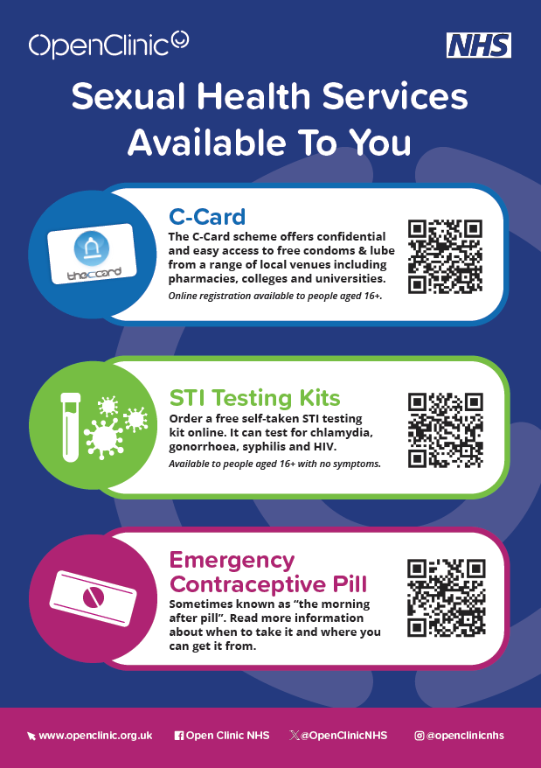
C-Card reminder

Please send C-Card paperwork by the 5th of each month to one of the following email addresses:
Stoke-on-Trent and North Staffordshire: SexualHealthOrders@mpft.nhs.uk
South Staffordshire: sexualhealthprevention@mpft.nhs.uk
Telford & Wrekin: telford.prevention@mpft.nhs.uk
Open Clinic NHS @openclinicnhs | @OpenClinicNHS
Sexual Health Services in Stoke-on-Trent, Staffordshire and Telford & Wrekin
0808 178 0955 | openclinic.org.uk
For more information on anything within this newsletter, or if you'd like to see anything included, please email SexualHealthComms@mpft.nhs.uk

